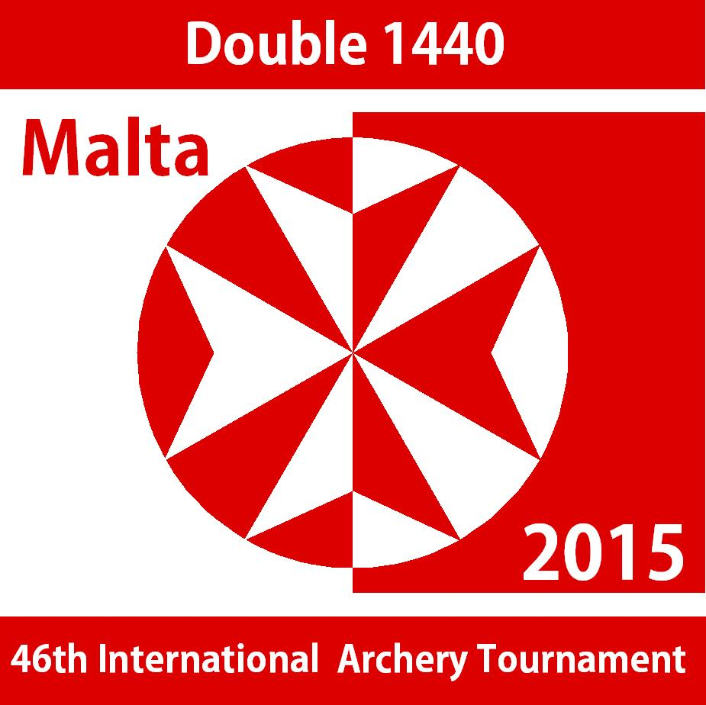
46th Malta International Tournament – 2015
Double 1440 - Entry Form
Date | Time
Friday – 17th April | 14.00 | Official Practice & Checking of Equipment
Saturday - 18th April | 09.00 | 1st Round Long Distances
Saturday - 18th April | 13.30 | 1st Round Short Distances
Sunday – 19th April | 09.00 | 2nd Round Long Distances
Sunday – 19th April | 13.30 | 2nd Round Short Distances
Sunday – 19th April | 17.30 | Presentation of Prizes

Venue: Archery Range – Marsa Sports Complex
Preliminary Registration: by no later than the 28th February 2015
Registration Fee/date: 50 Euros per athlete by 31st March 2015.
Payment method: Bank transfer to: Archery Association of Malta
IBAN: MT97VALL22013000000012000898019
Bank of Valletta
Swift Code: VALLMTMT
All additional bank charges are to your account

Prizes: Up to the first three athletes in each category.

Eligibility: Athletes must be members of Federation/Association affiliated to World Archery.

Athletes Details:

Name
Surname
Gender | Male/Female
Category | Cadet/Junior/Senior/Master
Division | Longbow/Barebow  /Recurve/Compound
Nationality
Contact | Email:
Athletes participating in this event do so at their own risk and accept to hold the Archery Association of Malta and its organisers fully indemnified against any possible theft, loss, damage or injury, including to third parties.

